THE PARTICLE BEAM OPTICS LABORATORY (PBO LAB) AS A TRAINING AND EDUCATION AID

George H. Gillespie, Barrey W. Hill, Hendy Martono,
John M. Moore, Nathan A. Brown and Michael C. Lampel
G. H. Gillespie Associates, Inc., P. O. Box 2961, Del Mar, CA 92014 U.S.A.

The Particle Beam Optics Laboratory (PBO Lab) is a new software tool developed as a training aid to support the teaching of particle beam optics. The PBOÊLab includes four key components: (1) a graphic user interface shell, (2) a graphic beamline construction kit for users to interactively and visually construct optical beamlines, (3) a knowledge database on the physics and technology of optical elements, and (4) various charged particle optics computation engines. The graphic user interface shell and beamline construction kit utilize a new Multi-Platform version of the Shell for Particle Accelerator Related Codes (S.P.A.R.C. MP), allowing the PBO Lab to run on a variety of machines including UNIX, Windows95/NT and Macintosh computers. Several computation engines are available, including the third-order TRANSPORT code and the ray tracing program TURTLE. The knowledge database is implemented with a combination of S.P.A.R.C. MP graphic components and a hypertext system - providing dynamic, self-directed, interactive tutorials (see Figure 1). The tutorial content is derived from a U. S. Particle Accelerator School (USPAS) undergraduate-level course that presented an introduction to accelerator optics. A prototype of the PBOÊLab was used in the USPAS course and the majority of the students were operators and operator trainees from several laboratories. The use of the PBO Lab as training aid will be described, and a demonstration using the Windows95/NT implementation will be presented.

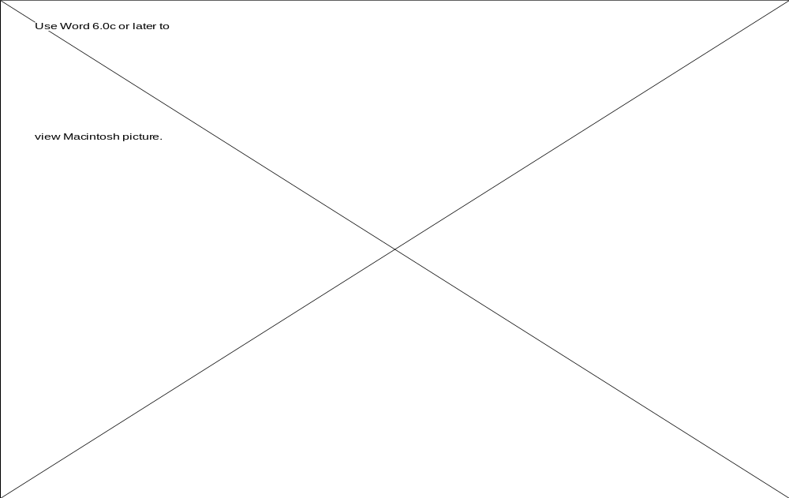

Figure 1. Selected windows from the PBO Lab running under Windows95.

